PARISH FIELDS PRACTICE

SUMMER 2026 PRACTICE NEWSLETTER



Welcome to our Summer 2026 Newsletter.
In this edition:

- May 2026 Practice statistics

- Vaccination update
- Covid
- Meningitis B

- NHS App

- My Planned Care

- Helping us to help you

- Practice Staff News
1.
MAY 2026 STATISTICS – PARISH FIELDS
Telephone Calls Received 3,578

Telephone Call Average Waiting Time 3.4mins

Appointments Booked 4,959

Prescription Items Issued 4,369
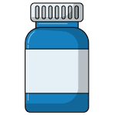
Online Requests Received 2,366

Patient Feedback 96%
(% rating Practice “Very Good” or “Good” in May 2026)

Did Not Attend Appointment 126

2.
As can be seen from the May 2026 statistics, the Practice remained very busy in May, delivering thousands of appointments and prescription items during the month.
We remain absolutely committed to giving patients a choice of how they contact the Practice, whether that is online, by telephone or in person at Reception.
We are also committed to being able to receive patient requests during Practice opening hours (Monday-Friday 8.00am – 6.30pm, excluding Bank Holidays), but it does help us to help you if you make us aware of any request for an appointment or advice as early as possible in the day, especially for urgent (non-emergency) requests,
Telephone call waiting times are important to us, which is why we have the following options for patients whose preference is to contact the Practice by telephone:
- Our automated telephone service, which opens at 8.00am on weekdays (excluding Bank Holidays), enables you to leave a message with how you would like the Practice to help you. This request is then forwarded to the Triage Team, led by a Duty Doctor, in the same way as an ordinary telephone call or online request is. There is never a queue on the automated service, regardless of how many calls are received at any one time.
- If you opt to use the manual telephone service and you are more than third in the queue, our system will give you the option to request a callback, which will occur at the same time that the call would have been answered had you had stayed on hold.
We were delighted to see average telephone call wait times at Parish Fields below 4 minutes in May 2026.
More and more of our patients are experiencing the benefits of using online services to interact with the Practice, including for requesting appointments. 68% of Parish Fields’ patients are now registered with the NHS App.
In addition to being able to request appointments, the Practice website, which is regularly updated, contains a host of helpful information and help on requesting repeat prescriptions, sick notes, test results, accessing your health record and managing NHS App notifications.
The Practice website can be found at: https://parishfields.co.uk/
Our Dispensary also had another busy month, including the further expansion of our home delivery service.
We would encourage patients who qualify to use our Dispensary (those living more than 1 mile as the crow flies from the nearest community pharmacy) to use this service at the Practice. Using the Practice’s Dispensary supports your Practice and enables further investment in patient services.
Please do speak to our Dispensary Team if you are interested in using our Dispensary, including our home delivery service.
3.
VACCINATION UPDATE
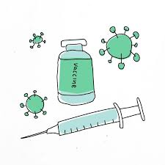
- COVID-19
Over 700 patients received their Spring 2026 Covid vaccinations at the Practice, many on additional Saturday clinics.
We would like to thank all of our staff who volunteer to work at these clinics over and above their weekly contracted hours, with a special mention to Practice Nurse Jess, who has again undertaken the considerable task of coordinating these vaccination clinics so efficiently.
We are also grateful to our Community Outreach Nurse, Cindy, who has again visited many of our patients who are not able to attend the Practice for their vaccinations.
Also, a huge thank you to our Patient Participation Group (PPG) volunteers who supported at these clinics. Please do contact the Practice if you are interested in learning about our PPG – we are always seeking new volunteers.

- Meningitis B
At the time this Newsletter is being written, news is breaking in respect of the announcement of a one-off vaccination programme to protect those at highest risk of Meningitis B disease ahead of the usual Autumn peak in meningitis in this age group.
Eligibility for this vaccination will be as follows:
- One-off Meningitis B vaccination programme to protect all Year 13 pupils, and those under 25 starting university or residential education for the first time this Autumn.
- Eligible students will need two doses for protection, with the first being offered from July, with the second dose given in August.
We understand that the programme is to be led via community pharmacy, commencing by the end of July.
Those eligible in Year 13 will be contacted directly through the NHS App, text or e-mail.
Those under 25 years of age and starting university for the first time will be able to book their appointments directly with a community pharmacy in due course.
4.
NHS APP
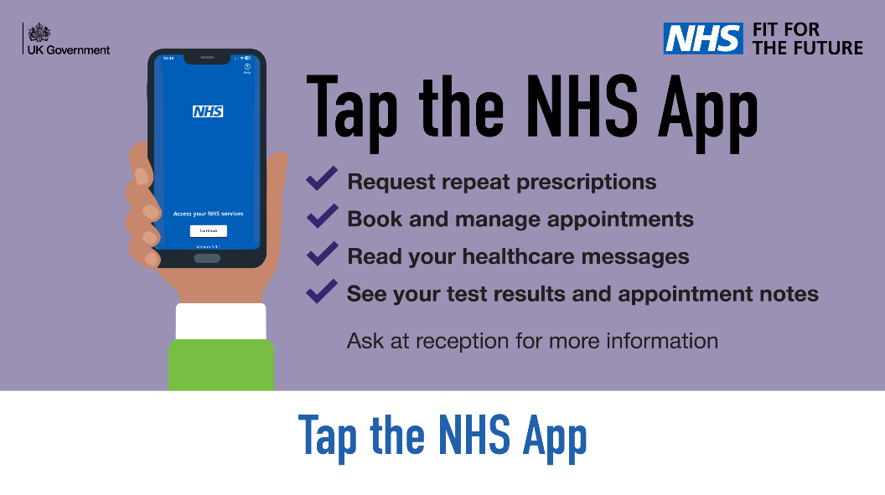
You can do more with the NHS App than you realise. Discover what else you can do today. The NHS App is available to anyone aged 13 years old and above.
By doing your bit and using the NHS App, it helps and supports us as a GP practice in so many ways. Not only does it reduce telephone calls to the Practice, but it also allows us to use automation and save valuable time – which, as we all know, is stretched.
We would really encourage all our patients to use the NHS App whenever they can. With a key pillar of NHS 10 Year Plan being the transition from analogue to digital, the NHS App will see constant development and new functionality being added.
Some of the NHS apps great features include:

Ordering medications
Viewing test results
Viewing notes, letters and consultations
Updating your contact details
Managing your upcoming GP appointments
Viewing and managing hospital appointments including referrals and waiting times
Receiving secure messages from your GP practice
Using 111 online to check your symptoms
Health A-Z
And so many more!

5.
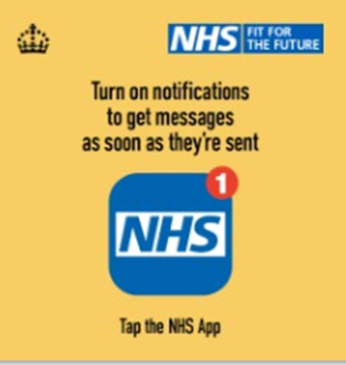
First things first…. Turn on notifications so that you are notified of any messages received from your surgery or local hospital. These can include appointment confirmation/reminders, invitations for vaccines etc.

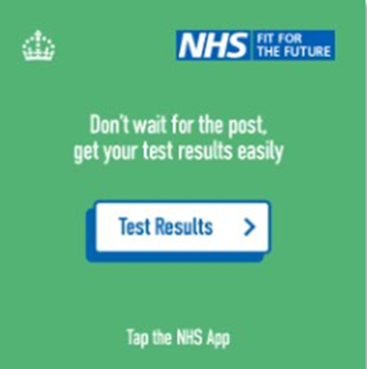
Test Results – View results for bloods, urine, and cervical smear to name a few, don’t wait around for the post or to make a call to the surgery, tap the app and have everything you need at your fingertips!

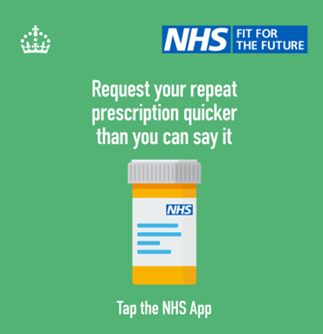
Medication – Request your repeat prescription more quickly than you can say it, when it suits you. You can also check the progress of prescriptions, see when you last ordered medication, obtain your prescription barcode for the pharmacy to scan and so much more.

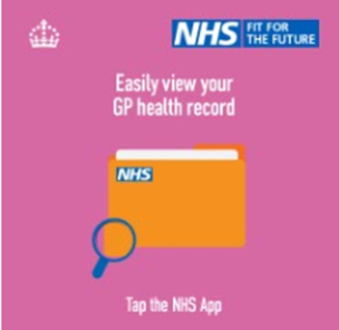

View your GP Health record at the touch of the button - This allows you to view appointment consultations, documents, allergies and sensitivities etc.
IF YOU NEED ANY HELP REGISTERING FOR, OR USING, THE NHS APP PLEASE SPEAK TO OUR RECEPTION TEAM WHO WILL BE HAPPY TO ASSIST

6.
WAITING FOR A HOSPITAL APPOINTMENT OR TREATMENT – INTRODUCING MY PLANNED CARE

If you have been referred by one of our clinicians to a hospital or specialist service, you are of course likely to want to know how long the wait is likely to be and what happens next.
To help patients access up-to-date information about hospital waiting times, the NHS provides a free service called My Planned Care. The link to My Planned Care is:
https://www.myplannedcare.nhs.uk/
This resource enables patients to:
- Check average wait times for your specific hospital and speciality
- Compare waiting times at nearby hospitals and treatment centres
- Find information about preparing for appointments, procedures or surgery
- Access resources to help you stay as well as possible and access advice and support during your wait
If you are waiting for routine hospital treatment or an appointment, we would encourage our patients to check My Planned care, which is updated regularly.
Once a referral has been accepted by the hospital, the hospital is responsible for managing your place on the waiting list and arranging your appointments.
HOWEVER, please contact Parish Fields IF:
- Your symptoms are worsening after the referral has been made or new symptoms are developing
- You are concerned your condition has become urgent
- You have been advised to seek further GP advice
- You have not received confirmation your referral has been submitted
The Parish Fields Team is here to support you, but for updates on hospital waiting lists My Planned Care is often the best source of up-to-date information.
My Planned Care can be found online at https://www.myplannedcare.nhs.uk/

7.
HELPING US TO HELP YOU
At Parish Fields we are open to all patient feedback and ideas on how we can continually strive to further enhance the care we provide to each of our patients.Please do continue to provide your feedback – all of which is read and the actions from which are discussed with our team.
To assist us further to help you, we would also like to ask our patients:
- Wherever possible, please use the check-in screen to the left of our Reception window when arriving for a pre-booked appointment. This avoids unnecessary queuing at the reception window and helps us to keep clinics running on time. PLEASE NOTE: The name which appears on the screen after you have input your details to the screen is the name of the CLINICIAN YOU ARE SEEING and NOT your own name.
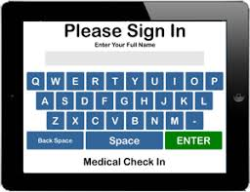
- Whilst our online forms, telephone system and Reception window are open Monday-Friday 8.00am – 6.30pm (excluding Bank Holidays), wherever practical, please let us know as early in the day as possible if you need an appointment or medical advice, especially if this involves a request for a home visit, or where you consider the appointment request to be urgent (non-emergency).

- If you cannot attend an appointment, please do let us know so we can offer the appointment to another patient. The number of Did Not Attend appointments has started to increase again (126 missed appointments in May 2026, equivalent to 5 days GP appointments lost in just 1 month).
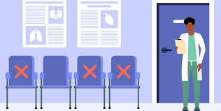
- If you have submitted an appointment request online or via our automated telephone service, please give our Triage Team time to assess your request and for them take the most appropriate clinical action. We sometimes have patients telephoning minutes after submitting their online request to check we have received it, which causes delays in speaking to other patients.
Also, please try and have your mobile switched on and ready to receive a call if you have made a request for an appointment/advice to avoid wasted clinician time.
8.


Since the last Practice Newsletter, Sarah Hanlon has joined the Practice as our full-time Clinical Pharmacist. Sarah brings extensive Clinical Pharmacist experience to the Practice, including most recently working for the Integrated Care Board (ICB).
Clinical Pharmacists are expert healthcare professionals who optimise medication use and improve patient outcomes. Operating across primary care (including GP practices) and hospital wards, their core duties include performing detailed medication reviews, managing chronic conditions, prescribing treatments, and ensuring seamless care during hospital discharges.

Dr Grazyna Grzleka joined the Practice in June as a Salaried GP and brings a wealth of clinical experience and expertise to the Practice. Dr Grzelka will initially be working at Parish Fields on Mondays and Tuesdays.

In July, we will be taking on a new Medical Secretary and we have been fortunate to recruit Dawn, who has many years’ experience in this role in a GP Practice. A GP Medical Secretary provides vital administrative support to a practice's clinical team. Their core duties revolve around processing patient referrals, audio typing clinical correspondence, and managing sensitive medical records. They bridge the communication gap between GPs, hospitals and patients, ensuring clinics run smoothly.
We would like to extend a very warm welcome Sarah, Dr Grzelka and Dawn to the Parish Fields’ team.

If you have any ideas or request for the content of future Practice Newsletters, please do let us know via e-mail at parishfields.recep@nhs.net , or feel free to come and speak to the Practice Manager/Assistant Practice Manager.

9.

