PARISH FIELDS PRACTICE
NEWSLETTER
CHRISTMAS 2025 and NEW YEAR 2026


REFLECTIONS ON 2025
As we near the end of 2025 we wanted to share some of the key points from the Practice in 2025.
The early retirement on ill health grounds of Dr Thorneley in March, and the tragic news of his passing in June obviously had a profound impact on all our staff, and many patients alike.
The outpouring of affection towards Dr Thorneley reflected his dedication to his profession and the care he unfailingly provided to his patients – including his 15 years at Parish Fields, most recently as Senior GP Partner.
Our thoughts and prayers remain with Dr Thorneley’s family.
Our staff have rallied this year, under the leadership of Dr Varghese as the new Senior GP Partner, and Dr Wilde as GP Partner, to continue to provide the best possible care to all our 8,200 patients - as Dr Thorneley would have wanted us to do.

APPOINTMENT/TELEPHONE/ONLINE REQUESTS:
2025 has certainly been a very busy year for the Practice.
For the 11 months ending 30th November, the statistics speak for themselves:
Number of appointments booked: 59,843

Number of telephone calls: 65,371
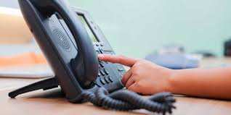
Number of online requests received: 24,856

We have thankfully seen a reduction in the number of appointments lost where patients did not attend their appointment and did not let us know in advance. Unfortunately, there were still 1,382 appointments not attended in 2025, equivalent to wasting 55 DAYS of 1 clinician’s time.
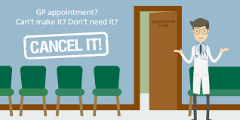
Whilst we appreciate that emergencies and unforeseen events mean that there will always be occasions when you cannot inform us you will not be able to attend an appointment, we would urge all our patients to please let us know whenever possible so that your appointment can be rescheduled and we can offer your cancelled appointment to another patient.
KEY PRACTICE DEVELOPMENTS IN 2025
Our automated telephone service was fully established enabling patients to request appointments and repeat prescriptions via the telephone between 8.00am and 6.30pm on weekdays (excluding Bank Holidays). This service is available via our main Practice telephone number (01379 642023) and simply requires the patient to leave a message on how the Practice may help. All such requests are reviewed by our Triage Team under the leadership of a Duty Doctor.
For patients preferring to speak to our Reception Team, our telephone system has a callback facility whereby patients have the option of requesting callback of they are more than third in the queue. This call will be at the same time that the call would have been answered had the patient opted to hold on the call.
September saw a major change to our appointment booking system with all 3 of our appointment request systems (Online, Telephone and Face to Face at our Reception desk) remaining open from 8am through until 6.30pm each weekday (excluding Bank Holidays). The Practice then has 1 working day to respond to these requests.


In October our Dispensary opening hours were extended so that our Dispensary is open from 8.30am until 6.30pm Mondays to Fridays (excluding Bank Holidays) including all through the lunchtimes.
To keep our patients informed about developments at the Practice we provide a regular newsletter (which is also available in our website and Facebook page), we have had 2 Practice Open Evenings at Roydon Village Hall, and our Patient Participation Group (PPG) continue to provide excellent support to the Practice which we are extremely grateful for. We always welcome feedback on how we can further enhance our communications to patients.

Most recently we have had a number of Saturday vaccination clinics for flu and Covid-19 vaccines. So far this flu/Covid-19 season, the Practice has administered approximately 3,000 vaccines.
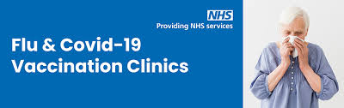
The organisation and planning of these vaccination clinics is a significant undertaking, and I would like to pay tribute to our team at Parish Fields for all of their work to deliver so many vaccinations. Many of our staff volunteer to do extra weekend shifts, after an already long and busy week, so that these vaccinations can be administered without reducing our appointment capacity during the week.
I would also like to sincerely thank members of our PPG and other volunteers who willingly give their time to help marshall patients and support these vaccination clinics – we are most grateful for their continued support.

PLANS AND PRIORITIES FOR 2026

Our number 1 priority at Parish Fields will always be to strive to provide the best possible level of care for each of our 8,200 patients and to treat every patient with compassion and empathy.
To help us achieve this in 2026, our plans include:
- Expanding our Dispensary service to include a home delivery service. Further details of this will be communicated by the Practice in the first Quarter of 2026
- Continuing to work with our PPG and ensuring that our patients receive regular communication and updates from Parish Fields via a variety of channels
- Continuing to invest in the training and development of our Practice team
- Contributing towards the NHS 10 Year Plan, which includes a transition from analogue to digital, aiming to use digital technology to maximise the effectiveness and efficiency of the Practice
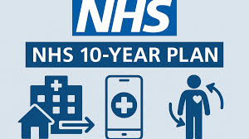

- Helping our patients who do not currently have access to the NHS App to gain access to this excellent resource
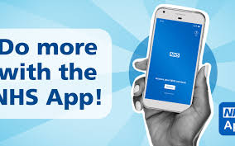
WHY IS THE NHS APP SO IMPORTANT IN 2026 AND BEYOND?
The NHS App will become the key gateway to all NHS services from 2028 onwards. We will be providing further training to all of our staff to ensure that they can assist patients with gaining access to the NHS App.
WHAT CAN I USE THE NHS APP FOR?
The NHS App is a simple and secure way of accessing a range of NHS services including:
- Ordering repeat prescriptions
- Nominating the pharmacy you would like to use
- Manage your appointments
- View your GP health record to see information such as your allergies and medication
- See information such as your test results
- Book and manage Covid-19 vaccinations
- View your NHS number
- Use NHS 111 online to answer your questions and get instant advice or medical help
- Message your GP surgery via an online form
- Access health services on behalf of someone you care for
- View/manage your hospital and other healthcare appointments
WHAT IF I DO NOT HAVE A SMARTPHONE?
You can still access the NHS App on a tablet or on a PC/laptop via a web browser by logging into the NHS website.
Alternatively, you can ask a trusted relative or friend to have access to your health record via their NHS App
HOW DO I ACCESS THE NHS APP?
You will need to set up an NHS login to prove who you are
Your NHS App then securely connects you to your information from the GP Surgery
WHAT TIMES IS THE NHS APP AVAILABLE:
The NHS App is available 24 hours per day, 7 days per week.
HOW CAN I GET MORE INFORMATION AND HELP ABOUT THE NHS APP?
- Access the NHS website page: https://www.nhs.uk/nhs-app/
- Ask our Reception staff for more information and help on setting up your NHS App
- Attend one of our NHS App Open events – the first of these being scheduled at Parish Fields on the morning of Tuesday 13th January 2026
- Our PPG will also be receiving training on accessing the NHS App in 2026 and have kindly volunteered to support additional NHS App Open Events at the Practice to help our patients gain access to the NHS App.
HELPING US TO HELP YOU IN 2026:
We are committed to working collaboratively with our patients in 2026.

We would ask that our patients consider the following in order to help us to help them in 2026:
- If we do not have your up-to-date contact details, for example, you change your telephone number or e-mail address please let us know. A page on our website (https://parishfields.co.uk/services/changing-your-contact-details/ ) is available for you to update your details, or you can advise us at Reception
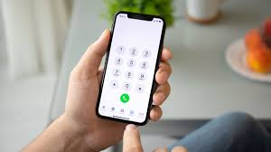.
- If we do not have your mobile telephone number, please let us know so that we can update our records and send appointment confirmation/reminders etc to you via text message
- If you have not done so already, please consider registering for the NHS App, as detailed earlier in the Newsletter
- Please arrive in good time for your appointments and, if wherever possible please use the check-in screen to the left of our reception window to check in. Please note the name displayed on the check in screen after you have checked in will be the NAME OF THE CLINICIAN YOU ARE SEEING and NOT your own name
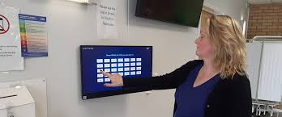
- If you have requested a call back from the Practice, or you have submitted a request for an appointment or medical advice, please have your mobile telephone with you and switched on ready to receive the call. Our clinicians regularly lose a lot of time making multiple telephone calls to the same number until they get a reply.
- Please try and submit non-urgent requests and test result requests (if you do not have NHS App access) after 2pm on weekdays (excluding Bank Holidays).
- Please understand that when our Reception Team ask you for more information about your request, this is in order that they can provide as much relevant information to our Triage Team as possible, in order that you get the appointment/advice from the most appropriate member of our clinical team. Our Reception team are there to help you.
FUTURE NEWSLETTERS AND PATIENT COMMUNICATIONS:
We will continue to keep our patients up to date with Practice updates via Newsletters and social media updates in 2026. Please do let us know what you would like to see included in these updates.

Finally, I would like to sincerely thank our hardworking and dedicated team at Parish Fields, both clinical and non-clinical staff, who have again worked tirelessly in 2025 to provide the best possible care to our patients

May we take this opportunity to wish all our patients a peaceful Christmas and a happy and healthy New Year

Simon Round, Practice Manager, Parish Fields. 16th December 2025

