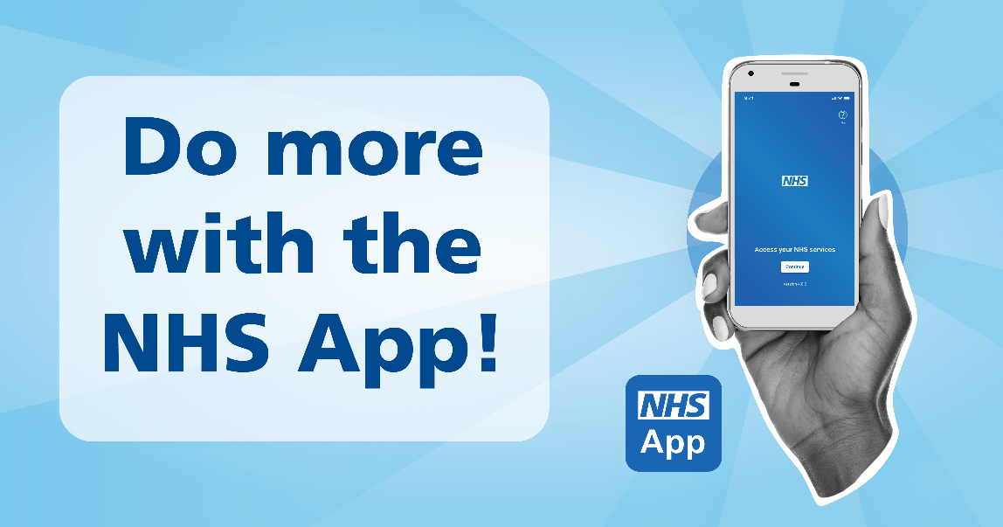
To try and help as many of our patients as possible we are holding an NHS App Day on Tuesday 13th January 2026 from 10am to 12pm at the surgery. We will have members from the ICB here set up and ready to help anyone with any issues/questions they have with the NHS App. They can also help you get set up on the app if you need it, this includes if you would like help to be set up to see a family members’/loved one’s records. Please remember to bring photo ID with you and know your usual phone app store password as you will need these if you are setting up as a new NHS app user.
Please spread the word!

