**PARISH FIELDS PRACTICE**

NEWSLETTER

**AUTUMN 2025**

** **

Welcome to our September/October 2025 Practice Newsletter, much of which will be focussed on the significant change to our appointment request system which goes live on Monday 15th September 2025.

Looking back at the summer of 2025, the most notable aspect is that the demand on the Practice has been at very similar levels to January, a time when we would expect demand to be the highest because of the higher prevalence of winter related illnesses.

The following statistics from August illustrate this point:

* Number of patients registered at Parish Fields **8,192**
* Telephone calls received in August 2025 **5,305**
* Online requests received in August 2025 **2,096**

This gives a combined number of requests (telephone + online) of 7,401, equivalent to **over 90% of our patient base in 1 month**, or **370 patient requests each working day.**

In terms of actual appointments booked in August 2025:

* Appointments booked **4,471**
* Appointments Not Attended 98
* Appointment attendance rate  **97.8%**

Whilst it is positive that the number of appointments not attended fell below 100 for the first time in 2 years, this **still equates to the loss of almost 4 days of 1 clinician’s time.**

We would again urge patients to let us know if they cannot attend appointments so that these appointment can be offered to another patient.



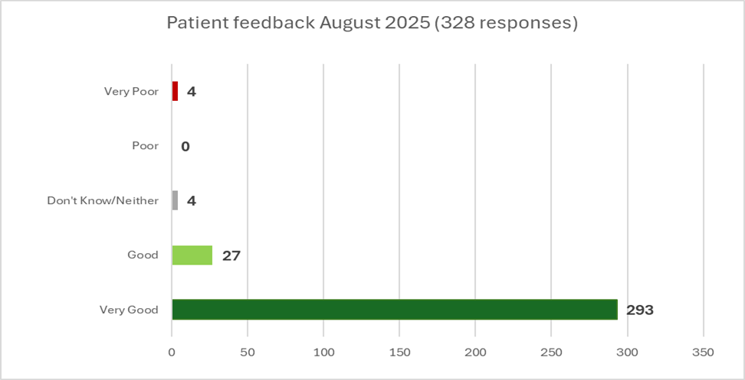

Thank you to all the patients who provided feedback following appointments attended in August, the results of which are summarised above.

We were delighted that almost 98% of patients rated their experience of the Practice as “Very Good” or “Good” in August.

We review each piece of feedback received, and our staff receive regular updates based on this feedback.

One piece of patient feedback that occurs regularly is regarding appointments running late. Whilst our clinicians do their best to keep clinics running in time, there are inevitably occasions when an appointment is more complex than anticipated. In these instances, appointments will, from time to time, not start on time.

The other common feedback is regarding the screen which our patients use to record that they have arrived for their appointment. The feedback often heard is that the screen is not showing their name for the appointment which they just checked in for. This is because our screen shows the **NAME OF THE CLINICIAN YOU ARE SEEING, NOT YOUR NAME.**

**NEW APPOINTMENT REQUEST SYSTEM EFFECTIVE 15th SEPTEMBER 2025**

********

**Monday 15th September 2025** sees the Practice launch a major change to how and when patients can request appointments and medical advice.

This change is to support the aim of “removing the 8am rush” for appointments and ensuring that our patients have a choice on how they contact the Practice.

**HOW DO I CONTACT THE PRACTICE TO REQUEST AN APPOINTMENT OR MEDICAL ADVICE?**

1. **ONLINE:** You can submit a request via the Practice Website ([www.parishfields.co.uk](http://www.parishfields.co.uk)) , and click on “Appointments”. Online access is available **from 8.00am until 6.30pm Monday-Friday**, EXCLUDING Bank Holidays
2. **TELEPHONE:** Between **8.00am and 6.30pm on weekdays** (excluding Bank Holidays), you can **telephone** us on **01379 642023** and select Option 1 to request an appointment. Your request will be reviewed by a member of our Clinical Triage Team led by the Duty Doctor. The telephone service from 8.00am to 8.30am is an automated service where you can leave details of your request for our Clinical Triage Team to review.
3. **FACE TO FACE**: At our Reception window between **8.30am and 6.30pm on weekdays** (excluding Bank Holidays)

Whether you make your request online, by telephone, or face to face at the Practice **ALL** requests are reviewed by our Clinical Triage Team led by the Duty Doctor. This is to ensure that all requests are reviewed on a clinical need priority basis as opposed to “first come, first served”.

Our Reception Team can **NOT** book appointments directly into GP appointments diaries because of every appointment needing to be reviewed by our Clinical Triage Team.

**WHAT HAPPENS AFTER YOU HAVE SUBMITTED YOUR REQUEST?**

The Clinical Triage Team will consider your request for an appointment or medical advice and tell you **WITHIN 1 WORKING DAY** what will happen next. this could be:

* An appointment that day or subsequent day
* A telephone call that day or subsequent day
* A text message responding to your query
* Advice to go to a pharmacy or another NHS service

**FLU & COVID-19 VACCINATIONS – AUTUMN/WINTER 2025**



This Autumn the Practice is again running vaccination clinics, including on **Saturday 11th October 2025** and **Saturday 25th October 2025**.

We are sending invitations to qualifying patients to book their Flu and Covid-19 vaccinations.

If you believe you are eligible for either/both of the vaccinations this year (**please see below for eligibility criteria**) please contact the Practice on 01379 642023.

**Who is eligible for the flu vaccine this year?**

The NHS recommends flu vaccination for several groups:

**From 1 September 2025**

* pregnant women
* all children aged 2 or 3 years on 31 August 2025
* children with certain long-term health conditions (aged 6 months to less than 18 years)
* primary school aged children (from reception to Year 6)
* secondary school aged children (from Year 7 to Year 11)
* all children in clinical risk groups aged from 6 months to under 18 years

**From 1 October 2025**

* everyone aged 65 years and over
* individuals aged 18 to under 65 with certain long-term health conditions
* care home residents
* carers in receipt of carer's allowance, or those who are the main carer of an elderly or disabled person
* those living with people who are immunocompromised
* frontline health and social care workers

**Who is eligible for the Covid-19 vaccine this year?**

For Autumn 2025, COVID-19 vaccination will be offered to:

* adults aged 75 years and over
* residents in care homes for older adults
* individuals who are immunosuppressed aged 6 months and over

**This represents a change from the Autumn 2024 Covid-19 programme, which also included adults aged 65 to 74 and all those aged 6 months and over in a clinical risk group.**

**BLOOD PRESSURE AWARENESS**

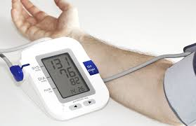

The Practice is focussing on the importance of patients knowing what their blood pressure is, and how they can seek medical advice.

**Risks of having high blood pressure**

If your blood pressure is too high, it puts extra strain on your blood vessels, heart and other organs, such as your brain, kidneys and eyes.

If it's not treated, it can increase your risk of serious conditions such as:

* [heart disease](https://www.nhs.uk/conditions/coronary-heart-disease/)
* [heart attacks](https://www.nhs.uk/conditions/heart-attack/)
* [strokes](https://www.nhs.uk/conditions/stroke/)
* [heart failure](https://www.nhs.uk/conditions/heart-failure/)
* [kidney disease](https://www.nhs.uk/conditions/kidney-disease/)
* [vascular dementia](https://www.nhs.uk/conditions/vascular-dementia/)

**Lowering your blood pressure even a small amount can help reduce your risk of these problems.**

In addition to the stand-up blood pressure machine on the left-hand side as you enter the Waiting Room, we have 2 portable blood pressure monitors for patients to use and hand in their blood pressure readings at our Reception Desk.

If you have any questions or concerns about your blood pressure, please do not hesitate to contact a member of our staff.



In August we welcomed Andrea, our new Dispensary Manager, to Parish Fields.

Andrea brings a wealth of experience in running a Dispensary to the Practice.

To give our patients better access to our Dispensary, **with effect from 6th October 2025** our Dispensary will be open Monday-Friday 8.30am – 6.30pm (excluding Bank Holidays), and will **NOT** close during lunchtimes on these days.

Dr Parbhakar leaves Parish Fields at the end of September to pursue another career opportunity. We would like to thank Dr Parbhakar for his contribution to the Practice, and for his care for our patients during his time at Parish Fields.

Current recruitment underway at the Practice includes Salaried GP and GP Assistant roles.

**PRACTICE NOTICE BOARDS**

Following feedback from our Patient Participation Group (PPG) we have reconfigured and decluttered the notice boards in our waiting room into the following categories:

* **Physical Health and Wellbeing**
* **Mental Health and Wellbeing**
* **Community**
* **Practice Information**
* **Patient Participation group (PPG)**

We also provide regular updates about the Practice and health related matters on our website as well as the Parish Fields and Diss Community Facebook pages.

**Patient Participation Group Update**



The role of a PPG is to represent the views of patients, and work with the Practice management team as we strive to constantly enhance the service and care we provide for our patients.

PPG members do need to be registered patients at the Practice but previous experience of being a PPG member is not required. The typical time commitment is around 2 hours per month (some of our PPG members give more than this to help at such events as signposting at vaccination clinics and at our Open Evenings).

If you are interested in becoming a member of our PPG please contact or visit the Practice or complete the PPG form on our website. Alternatively, the next meeting of the PPG is scheduled for **6pm on Thursday 25th September 2025**, being held on the ground floor of the Practice. If you would like to come along to this meeting to see what is involved with being a PPG member please contact the Practice beforehand.

**PRACTICE OPEN EVENING**



We are holding another Parish Fields Open Evening commencing at 7pm on Thursday 30th October at Roydon Village Hall.

At the evening you will be able hear updates from Parish Fields, and have the opportunity to provide feedback and ask questions.

Please let our Reception team know if you would like to attend this Open Evening.

**\*\*\*\*\*\*\*\*\*\*\*\*\*\*\*\*\*\*\*\*\*\*\*\*\*\*\*\*\*\*\*\*\*\*\*\*\*\*\*\*\*\*\*\*\*\*\*\*\*\***