PARISH FIELDS PRACTICE, DISS

PRACTICE NEWSLETTER

**JULY/AUGUST 2025**

 

Welcome to this edition of the Parish Fields Practice newsletter.

**Dr Thorneley**

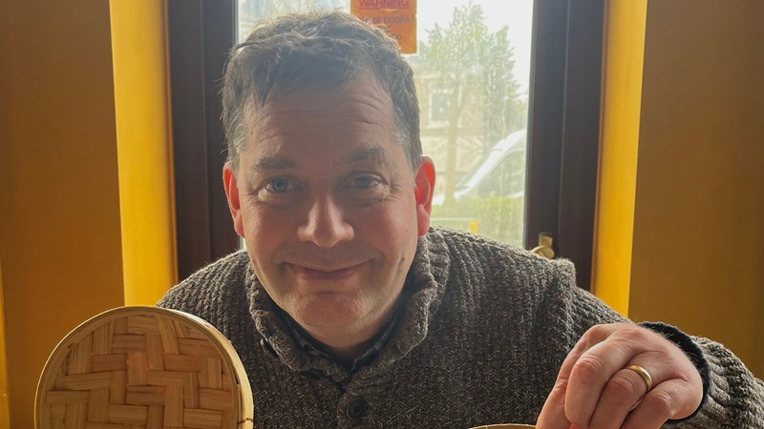

As many of our patients know, Dr Thorneley very sadly passed away on 5th June after a most courageous, inspirational battle with cancer over the past 6 months.

Parish Fields staff were able to attend a service at Barnham for Dr Thorneley on Friday 4th July.

Our thanks go to Norfolk and Waveney Integrated Care Board for permitting the temporary closure of the Practice for 4 hours on July 4th to enable staff to attend and pay their respects to a much loved and highly respected doctor, who had worked at the Parish Fields for many years, ultimately becoming Senior Partner, up until his retirement on ill health grounds earlier this year.

Our sincere thanks also go to our patients for their understanding.

Dr Thorneley’s family would like to thank everyone for the outpouring of sympathy and appreciation – including all those who signed the book of condolence at the Practice.

Dr Thorneley was cared for in his final days by St Nicholas Hospice at Bury St Edmunds (<https://stnicholashospice.org.uk/>) and his family will be eternally grateful for the exceptional care and kindness shown by all the staff at the hospice.

Dr Thorneley’s son has set up a Just Giving page to raise funds St Nicholas Hospice, which can be accessed at: <https://www.justgiving.com/page/st-nicholas-hospice-cwt>

**June 2025 Statistics**

In the first half of 2025, the Practice booked **31,602** appointments.

As can be seen from the following bar chart, demand for appointments remains high, even in the middle of Summer.

We continue to work to maximise the number of appointments available to our patients.

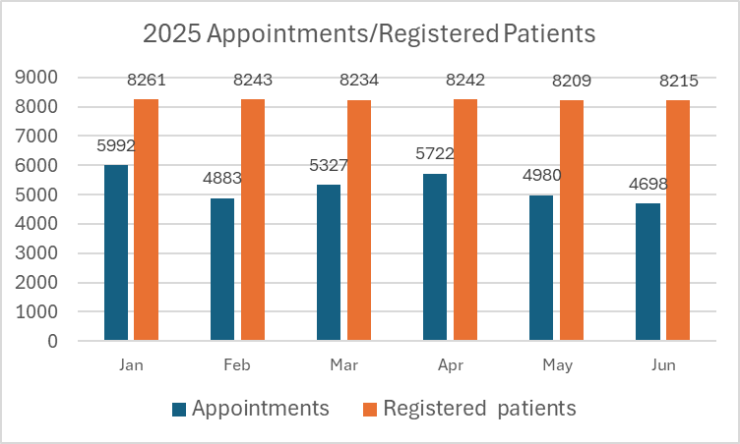

**Appointments booked but not attended**

There were **111 appointments** booked in June where the patiend did not attend, and did not advise the Practice in advance. The appointment was therefore wasted. Whilst this is an appointment attendance rate of 97.7% for June, it still equates to over 4 days of clinician time lost in 1 month.

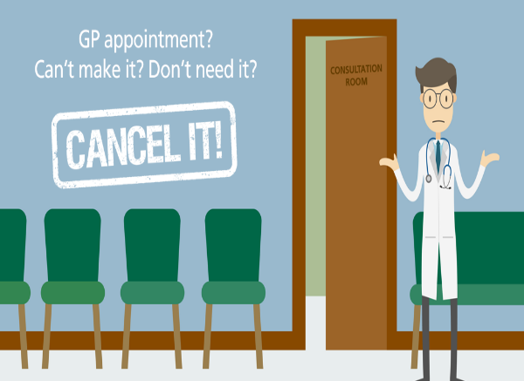

Please do try and let us know as soon as you do if you cannot attend an appointment so we can try and offer it to another patient. Appointments can be cancelled via the telephone, the NHS app, our website (<https://parishfields.co.uk/appointments/>), or in person at our Reception desk.

**Parish Fields Dispensary**

It was not only our clinicians, reception and administration teams that have been busy in the first half of 2025.

Our Dispensary team work tirelessly to ensure that our dispensing patients receive the medications they require in a timely and efficient manner



In June 2025 alone, our dispensary dispensed **4,728** items.

We would like to encourage all patients who are eligible to receive their prescribed medication (patients living more than 1 mile from a pharmacy) to support the Practice by using our dispensary.

**PATIENT FEEDBACK: JUNE 2025**



Thank you to the patients who spoke to Healthwatch Norfolk during their recent visit to Parish Fields

The full Healthwatch report on the Practice is available via the following link:

<https://healthwatchnorfolk.co.uk/reports/parish-fields-practice-feedback-report-june-2025/>

We were pleased with the report overall (which gave Parish Fields a “star rating” of 4.4 out of 5).

It is always nice for our hard working and committed staff to hear that they make a positive difference to so many of our patients lives.

It is of course equally important that we listen to and learn from feedback where the patient has been disappointed with the care or service they have received, and we welcome all feedback as we continually strive to provide the best possible level of care to each of our patients.

We would also like to thank the **264** patients who provided feedback via text following attending their appointments in June.

The summary of responses from this feedback is as follows:

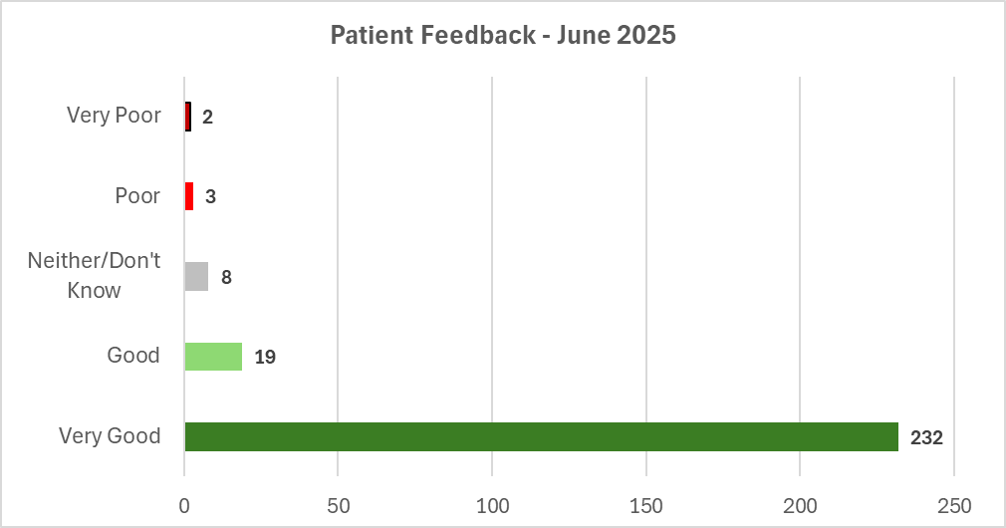

**Requesting Appointments**



A question that still arises frequently is “*how do I request a GP appointment*”.

At Parish Fields we aim to give parity of access to patients, whether their preference is to request an appointment online, or via telephone, or face to face at our Reception desk.

Currently we offer the following options to patients in respect of requesting an appointment:

1. **Telephone**

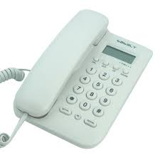

On weekdays (excluding Bank Holidays):

* **6.30 am – 9.00 am** via our automated telephone service
* **8.30 am – 6.30 pm** via telephoning our Reception team

**In both cases the telephone number is 01379 642023.**

Our telephone system has a callback facility enabling patients to reserve their place in the telephone queue, so holding in a long telephone queue is not necessary.

1. **Online**



Via our website (<https://parishfields.co.uk/appointments/>)

Urgent (non-emergency requests) can currently usually be submitted between **6.30am and 7.30am** each weekday (excluding Bank Holidays).

Nurse and HCA appointments can be requested online 24 hours per day/ 7 days per week but please remember **requests will not be reviewed whilst the Practice is closed.**

**For urgent (non-emergency) clinical advice when the Practice is closed please telephone 111.**

**IN THE EVENT OF A MEDICAL EMERGENCY PLEASE TELEPHONE 999 AND ASK FOR THE AMBULANCE SERVICE.**

1. **Face to face at our Reception Desk**

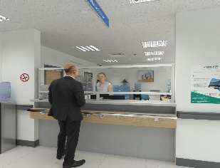

Weekdays (excluding Bank Holidays) **08:30am – 6.30pm.**

In all cases we would ask that you please contact the Practice as early in the day as possible.

**Patient Participation Group (PPG)**



We are most grateful to the members of our PPG who give their time to support the development of the Practice and provide the Practice with valuable feedback from a patient’s viewpoint.

We are currently looking for additional members for our PPG.

**If you are interested in learning more about what a PPG does please do contact the Practice via telephone (01379 642023), or via our website (**[**https://parishfields.co.uk/surgery-information/patient-group/**](https://parishfields.co.uk/surgery-information/patient-group/)**)**

The next meeting of our PPG will be at **6pm on Thursday 7th August 2025** at Parish Fields Practice. If you would like to come along to that meeting to see what is involved with being a PPG member, please telephone us on 01379 642023 ahead of the meeting.

**Staff News**

In June we welcomed 2 new Salaried GPs to the Practice.

**Dr Vynika Thirumala** joined Parish Fields on 6th June and **Dr Lucy Boyles** started at the Practice on 24th June.

We would like to warmly welcome both Dr Thirumala and Dr Boyles to Parish Fields.

This takes the Practice to 6 permanent GPs, plus support from 2 regular locum GPs.

**Heatwave: How to cope in hot weather**



As we find ourselves in another heatwave at the time of writing this newsletter, it is important to remember the dangerous impact hot weather can have on our health.

Just as cold weather in Winter can be dangerous to health, during heatwaves more people than usual get seriously ill or die.

The main risks posed by heatwaves are:

* Dehydration – not drinking enough water
* Overheating – worsening symptoms for those who have heart or breathing conditions
* Heat exhaustion
* Heatstroke

Tips for helping to reduce the risks to health in hot weather:

* Have cold food and drinks to help avoid dehydration
* Avoid alcohol, caffeine and hot drinks
* Try to keep in the shade when outdoors
* Keep living spaces cool by closing windows in the day and open them when the temperature outside drops

The NHS has produced a useful guide on how to stay well during hot weather and includes and this guide can be found via the following link:

<https://www.nhs.uk/live-well/seasonal-health/heatwave-how-to-cope-in-hot-weather/#:~:text=Tips%20for%20coping%20in%20hot,Cool%20yourself%20down>.

This also includes a link to sunscreen and sun safety (<https://www.nhs.uk/live-well/seasonal-health/sunscreen-and-sun-safety/>)

That’s it for the Practice Newsletter this month.

If there are topics you would like to see covered in future editions of this newsletter, please do let us know.

Simon Round

Practice Manager

11th July 2025