**THE PARISH FIELDS PRACTICE**

**APRIL/MAY 2025 NEWSLETTER**

** **

Welcome to our April/May 2025 newsletter.

This newsletter is onger than usual as it includes a summary of the content from the Practice Open Evening held on Thursday 10th April 2025.

The Practice has continued to be extremely busy over recent weeks, as illustrated in the following statistics:

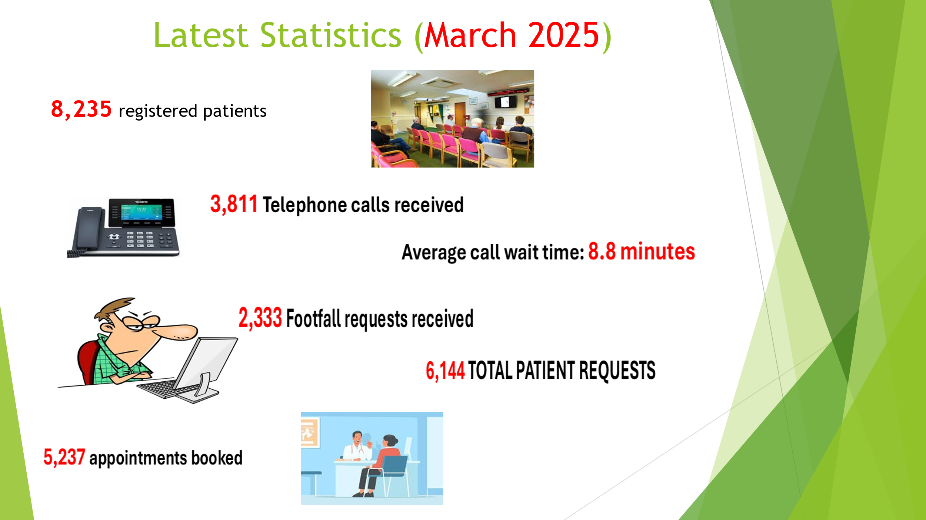

(Footfall being the system that we utilise to manage all online requests received from patients).

As can be seen from this information, the equivalent of almost 75% of our entire patient base of 8,235 patients made contact with the Practice in March 2025 alone.

Our thanks go to the patients who provided text message feedback following their attending appointments at Parish Fields in March 2025, the results of which are summarised as follows:

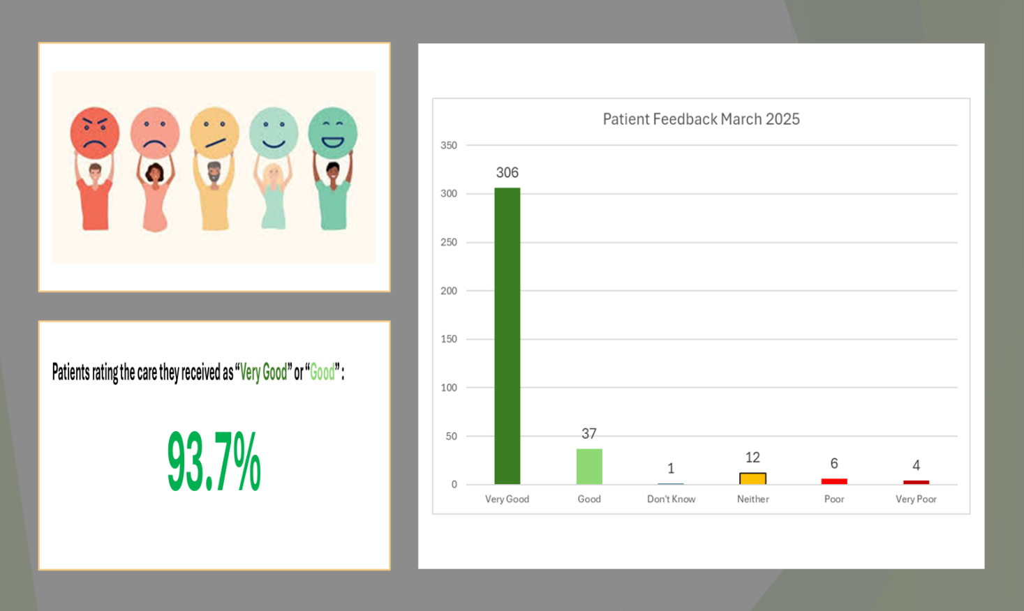

**PARISH FIELDS PRACTICE OPEN EVENING: 10th APRIL 2025**

On the evening of 10th April, we held our Practice Open Evening at Roydon Village Hall.

I would like to firstly thank all of our staff who supported this evening, which for some of our staff resulted in a 14-hour working day as they attended the evening after a busty day in clinic. Other staff attended on their day off, or from their annual leave to support the evening.

Sincere thanks also go to all the patients who gave their time to attend the evening, and also to our Patient Participation Group (PPG) who,, once again, provided excellent and much appreciated support to the Practice.

Thank you also to the management committee of Roydon Village Hall for providing such a good venue for this event.

For those patients unable to attend, we thought it would be useful to summarise the content of the Open Evening in this newsletter.

We started by looking at how GP practices in England are funded. As detailed in the following slide:

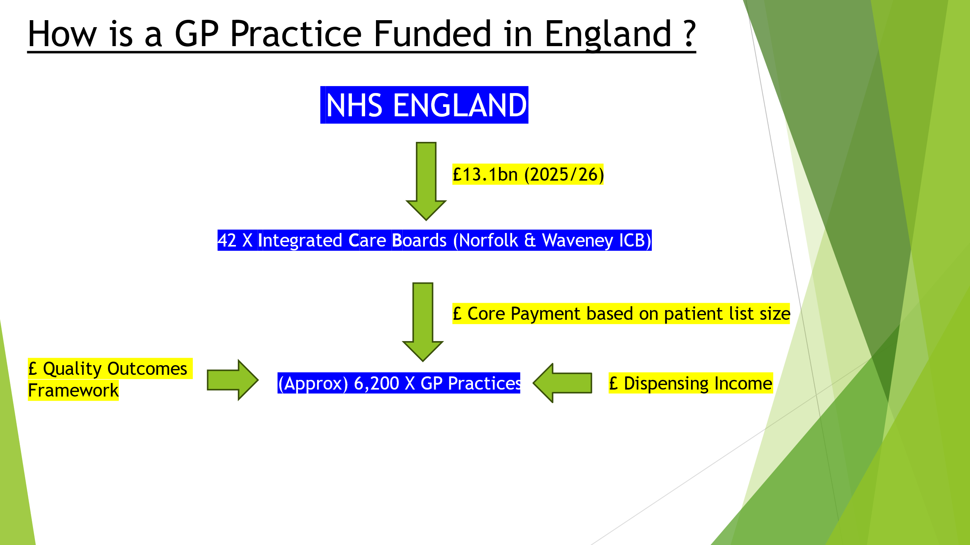

This information is important for patients to understand, as it demonstrates that GP practices have a finite budget, which must be adhered to if the practice is to remain financially viable.

We sometimes receive feedback, especially via social media, asking questions such as “why don’t they (GP practices) just employ more doctors?” etc, so hopefully this slide and the following on expenditure explain why this is not always possible:

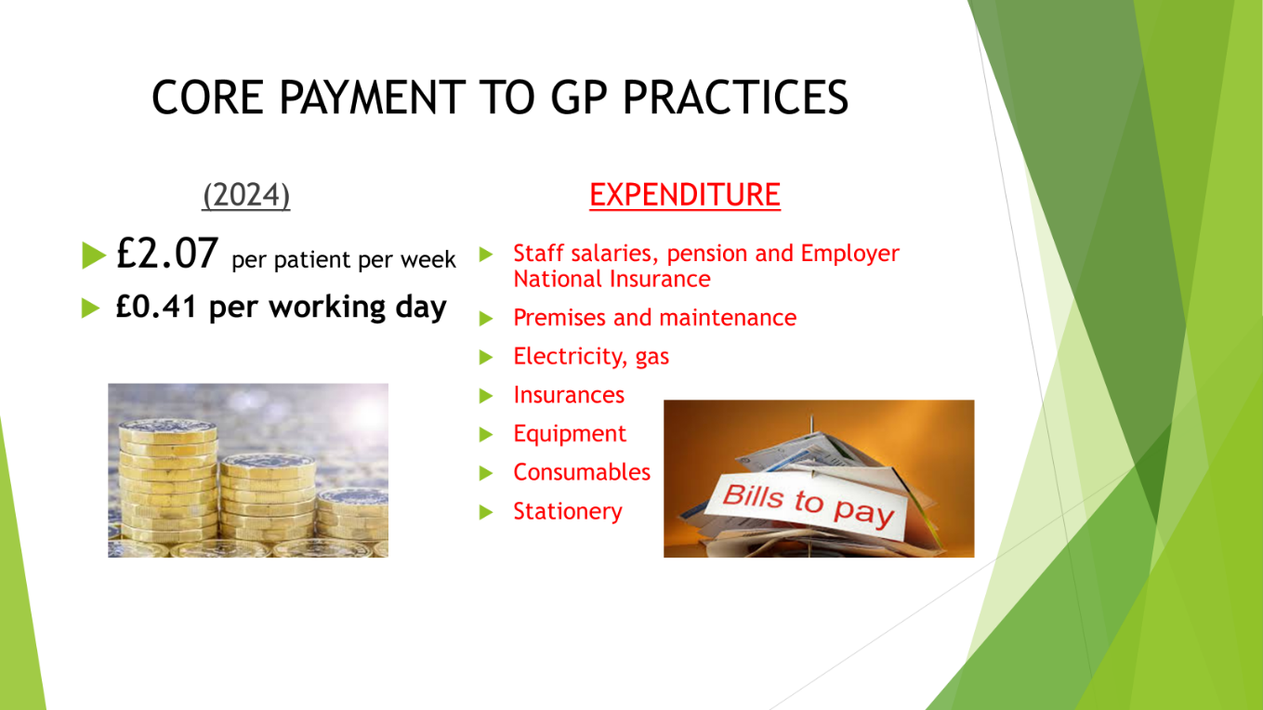

GP Practices are receiving a welcome increase to their income in 2025/26, but the fact remains that the budget still has to balance against a backdrop of inflation, energy cost uncertainty, wage cost pressures, and a significant increase in employer National Insurance costs.

We went on to look at pressures on the system nationally:

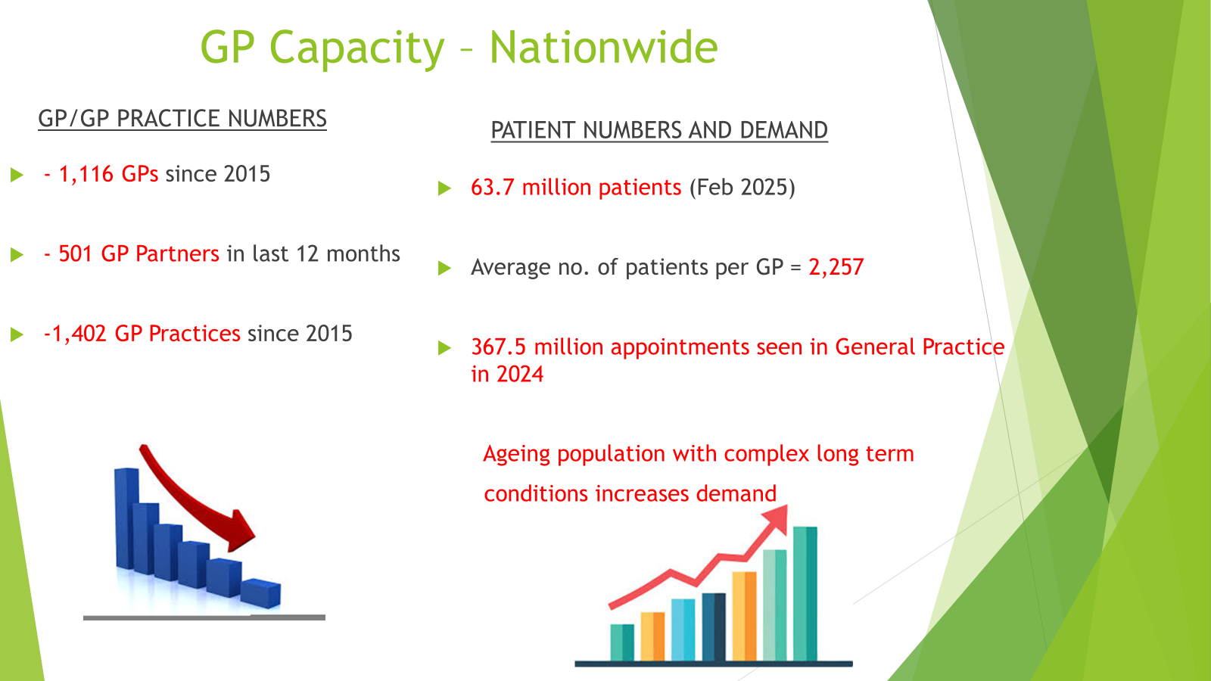

In summary, as can be seen, demand continues to rise, and whilst the number of GP appointments booked has also risen since 2020, meeting patient demands remains a significant challenge.

We then moved on to look at the Parish Fields Practice in more detail.

Providing the best possible level of care to each of our patients remains our number one priority, and everyone at the Practice works extremely hard each day to try and achieve this aim. Our staff have annual appraisals, with our non-clinical staff being appraised against a set of “Core Standards”. These Core Standards are detailed on the following slide:

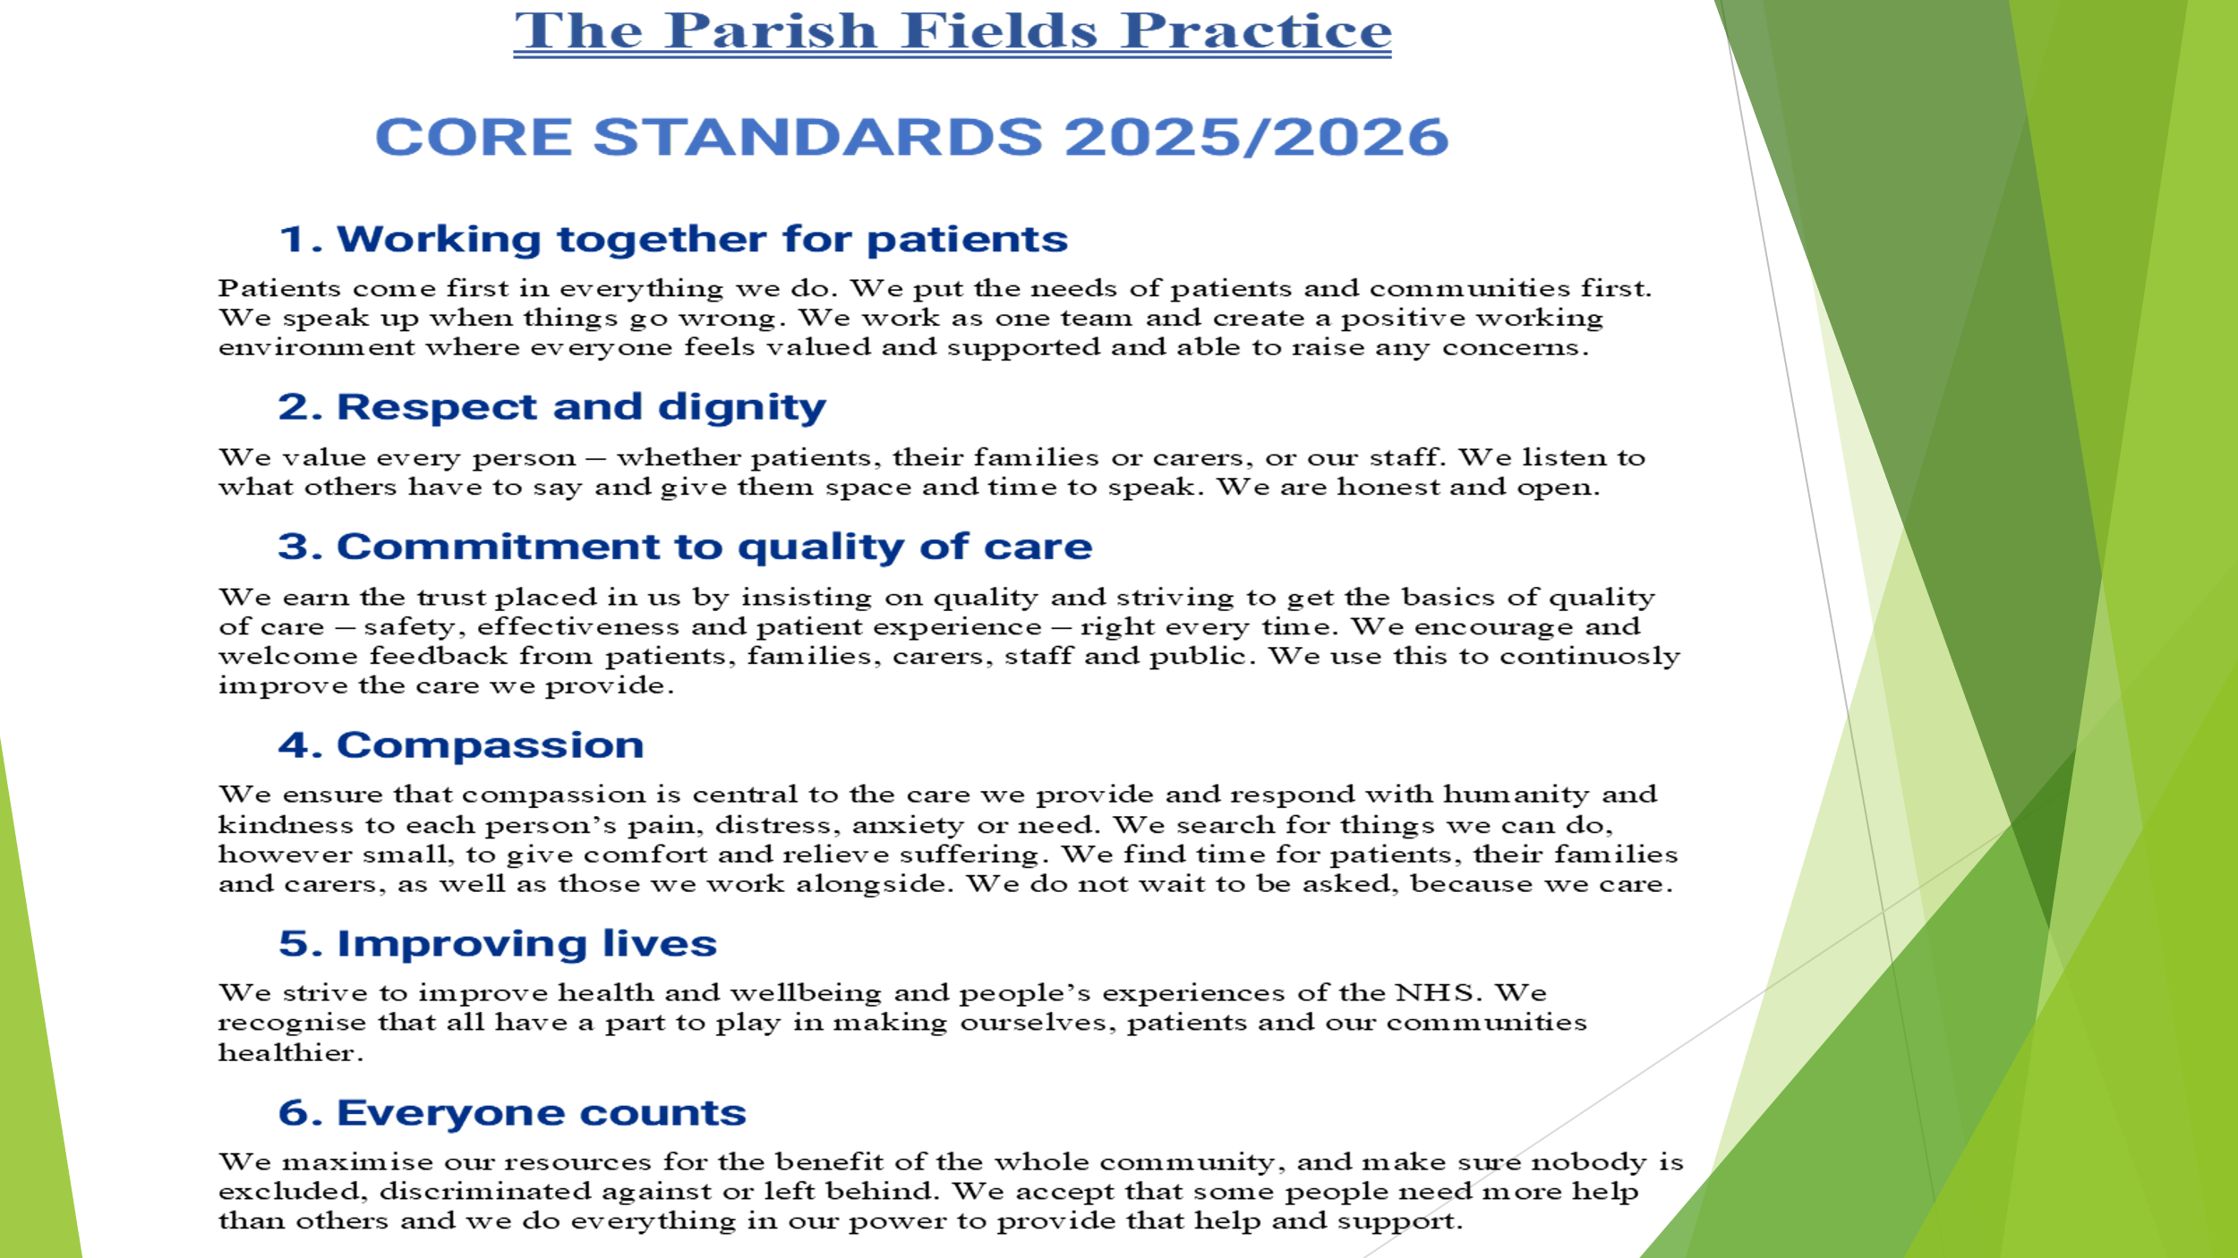

We welcome all patient feedback, which is all reviewed and discussed with our staff as part of the ongoing staff learning and enhancement of the level of care, we provide to each of our patients.

We then moved on to look at the job roles at Parish Fields:

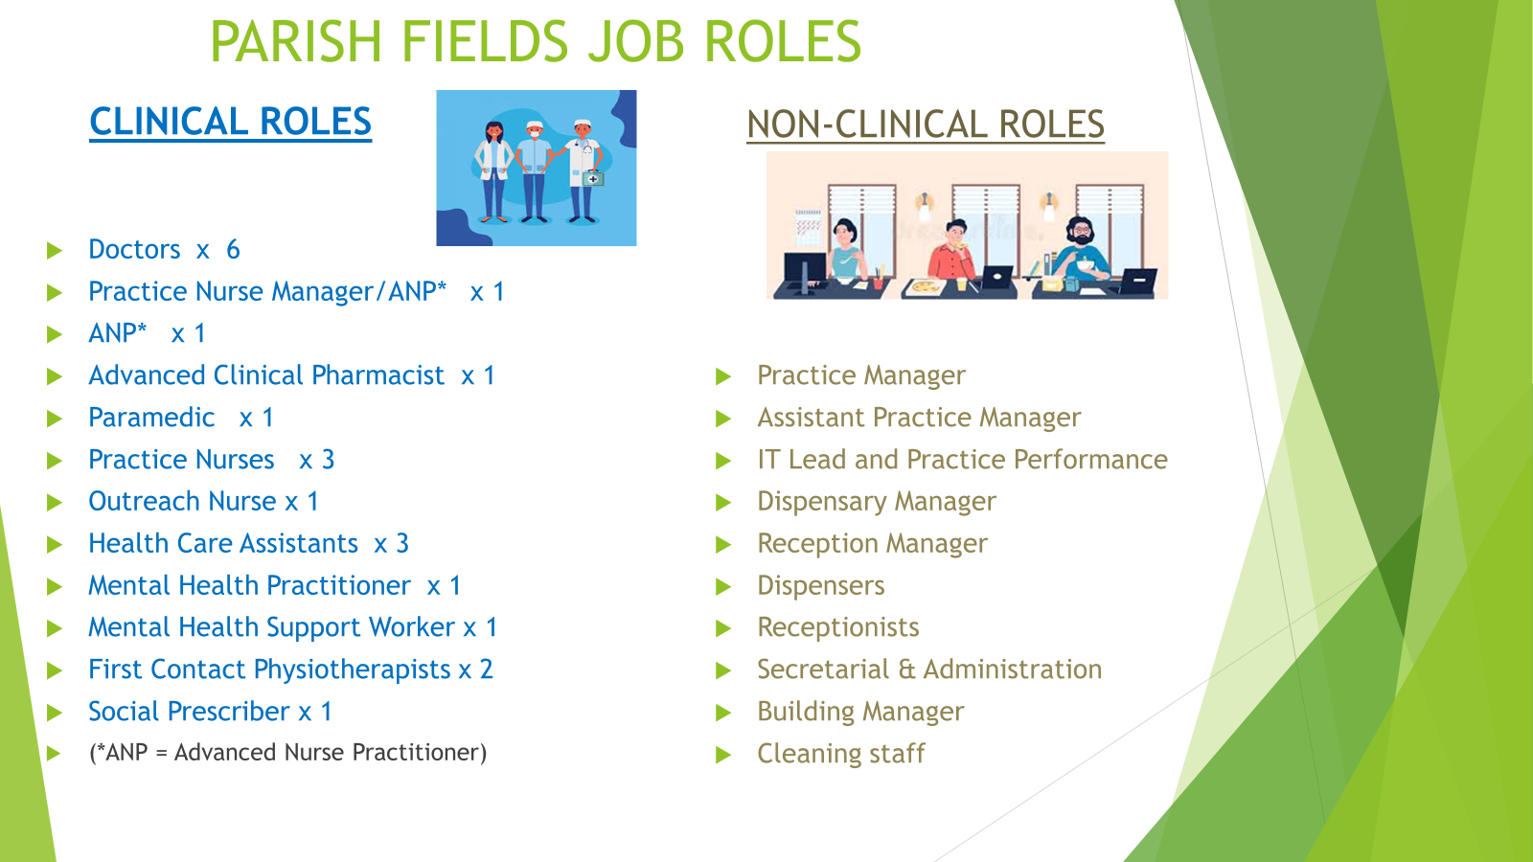

As can be seen, the roles are clinical and non-clinical roles, the core role of all non-clinical staff being to support our frontline clinical team. For example, the role of a receptionist is so much more that answering the telephone and booking appointments.

Diane, an Advanced Nurse Practitioner and Practice Nurse Team Manager, went into more detail regarding the clinical roles at the Practice. This included outlining the additional study and qualifications that the Nursing Team have completed/are working towards, which means that they see an increasing number of patients and conditions.

Diane also explained the triage system at the Practice, which involves all appointment requests being triaged by a team led by our Duty Doctor, to ensure that appointments are allocated on a clinical need basis, as opposed to being on a “first come, first served” approach.

We also had a look at GP/Clinician workload. As the following illustrates, the GP/Clinician’s Day is far from only seeing appointments. The resulting workload from appointments is significant and often sees our clinical team often working late into the evening and at weekends.

Appointments themselves are effectively the tip of the iceberg in respect of workload.

It is also important to realise that a telephone appointment **is an appointment**, as these telephone calls use clinician’s time in the same way that face-to-face appointments do.

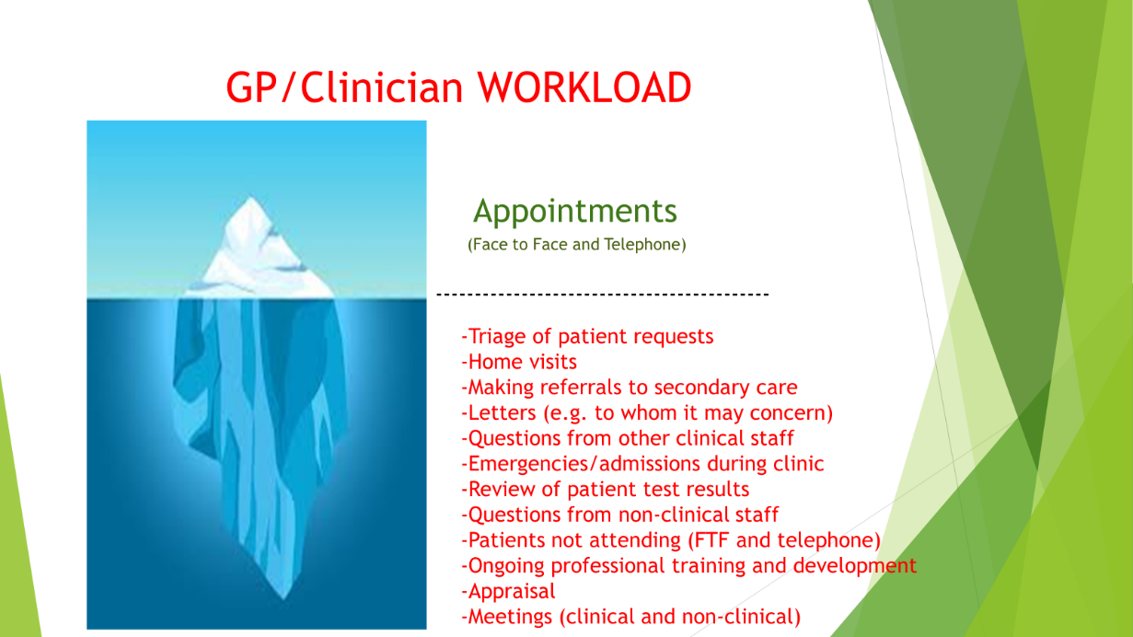

Hopefully this slide explains why clinicians’ cannot simply routinely take an unscheduled telephone call on the basis that “I don’t need an appointment, I only need to speak to the Dr for 5-10 minutes”, a request which we do often hear.

Patient access to the Practice understandably remains a key priority for our patients and, consequently, for the Practice Team. At the Open Evening we discussed the following information which details how patients can currently access the Practice:

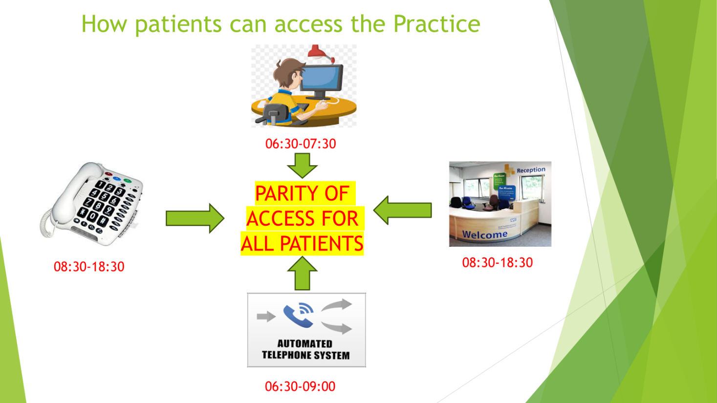

As can be seen, parity of access for patients is very important. By this we mean that patients interacting with the Practice to request appointments via the 3 key channels:

**-Telephone**

**-Online**

**-Face to Face at our reception desk**

have an equal opportunity to do so, thereby meaning that patients without online access for example our not disadvantaged.

**Wherever possible, we ask that patients seeking a same day appointment do so as early in the day as possible.**

Linked to patient access and availability of appointments is the number of appointments booked, but which are not attended, and where the Practice does not receive notification in time to offer the appointment to another patient.

As can be seen from the following bar chart, the number of such appointments is over 1,600 at Parish Fields in the past 12 months. **This equates to over 400 hours of lost clinical time.**

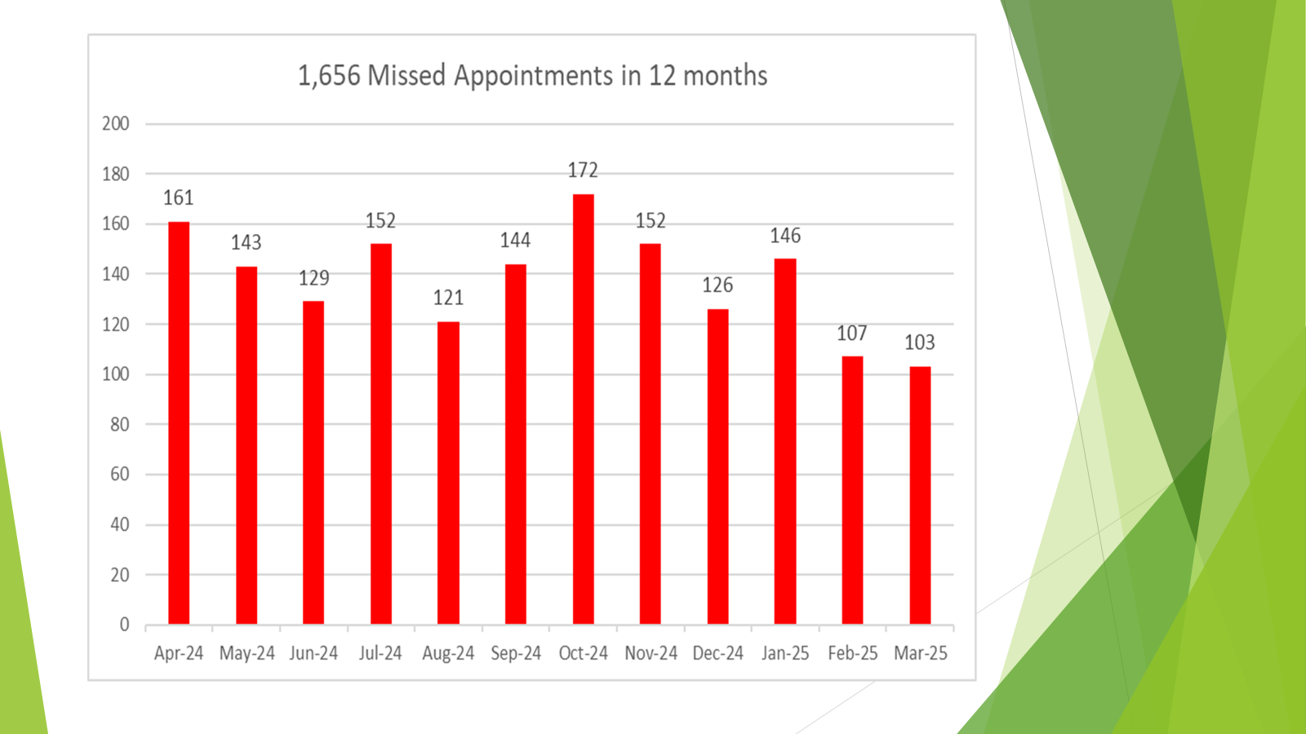

Whilst the trend is positive, and we do appreciate that there are some genuine cases where it was not possible for the patients to update us in time, we would like to further reduce the numbers of missed appointments, and would remind patients that the following options are available to them to cancel an appointment which they can no longer attend:

* Telephone the Practice (appointments can be cancelled 24 hours per day, 7 days per week by telephoning the Practice on 01379 642023 and selecting option 1 to access our Automated Telephone System). **THERE IS NEVER A QUEUE ON OUR AUTOMATED TELEPHONE SERVICE, REGARDLESS OF HOW MANY PATIENTS ARE UTILISING IT AT ANY ONE TIME.**
* Online via the Practice website: ([www.parishfields.co.uk](http://www.parishfields.co.uk))
* Reply to the appointment confirmation/reminder by text message
* Visit our reception Desk in person

We then moved on to the work and projects implemented in 2024, and our plans for this year and beyond…

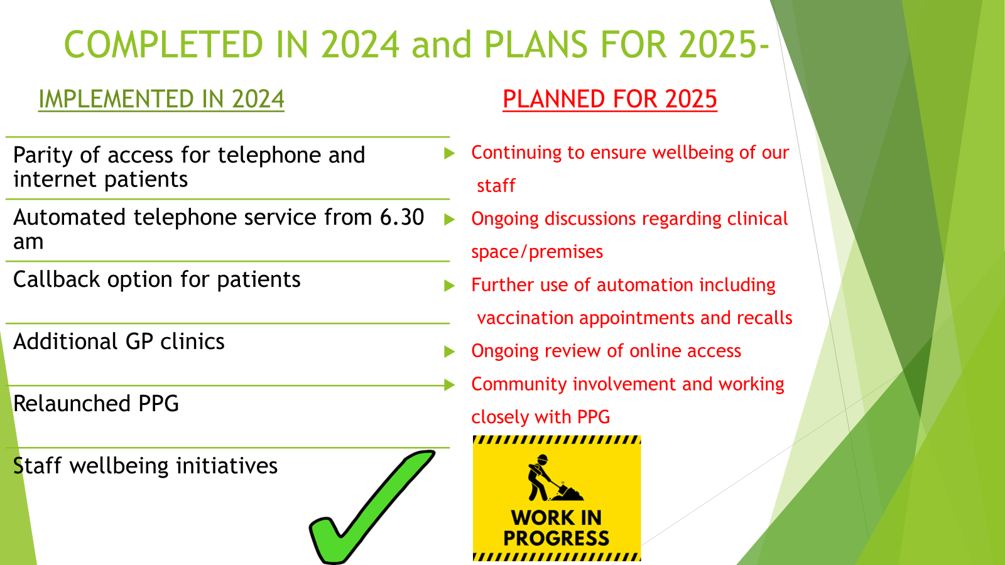

Staff wellbeing remans a key priority for the Practice, with the welfare and retention of our staff being intrinsically linked to staff retention and patient care.

We hear much feedback from patients regarding their concerns over the growing population locally, and the demand that this places on local services, including GP practices. We continue to work closely with the Norfolk and Waveney Integrated Care Board (ICB) and other relevant parties as we explore how additional clinical space can be obtained by Parish Fields and utilised in Diss over the coming years.

We also discussed the topic of patient feedback and the impact of social media.

The first thing to say on this is that we appreciate that occasionally systems and/or processed go wrong, or we do not meet the expectations of our patients. We are totally committed to a process of continuous improvement in order to deliver the best possible levels of care to each of our patients.

To support this, we welcome all feedback from patients, all of which is carefully reviewed and discussed at various meetings at the Practice, involving all of our staff.

There are multiple channels available for patients to submit this feedback, including via our website, paper forms at the Practice, contacting our PPG, or requesting an appointment with practice management.



We discussed the significant adverse impact of a minority of social media posts, especially the impact upon our hardworking and committed staff.

Many of our staff live in and around Diss and have, on occasions, been distressed and disheartened to read some of the posts on local social media, most of which have been posted without the writer having raised their concerns with the Practice directly. Sometimes these posts contain information which is simply incorrect.

Our plea then at the Practice Open Evening, and again via this Newsletter, is to ask our patients to please think carefully before posting on social media, and instead, consider speaking to us directly with any concerns you have in order to give us a chance to review and respond.

Our staff are well trained and highly experienced. They are recruited on the basis not only of their knowledge, qualifications and expertise, but also on their empathy and care for people.

They therefore all understand that patients are sometime frightened, anxious or frustrated and may not be at their best when they speak to the Practice. This is totally accepted and understood by all of our staff,

Unfortunately, however we do witness, on a very small number of occasions, behaviour from patients which crosses an acceptable threshold even allowing for the factors detailed above, Such behaviour includes threatening/abusive language or actions and/or foul language aimed at our staff.

The Practice does have a zero tolerance policy towards such behaviour, and will not hesitate to act accordingly in these circumstances, including, in extreme cases, seeking to remove the patient from the Practice Patient List.

We concluded this section of the Open Evening on how patients can help us to help them:

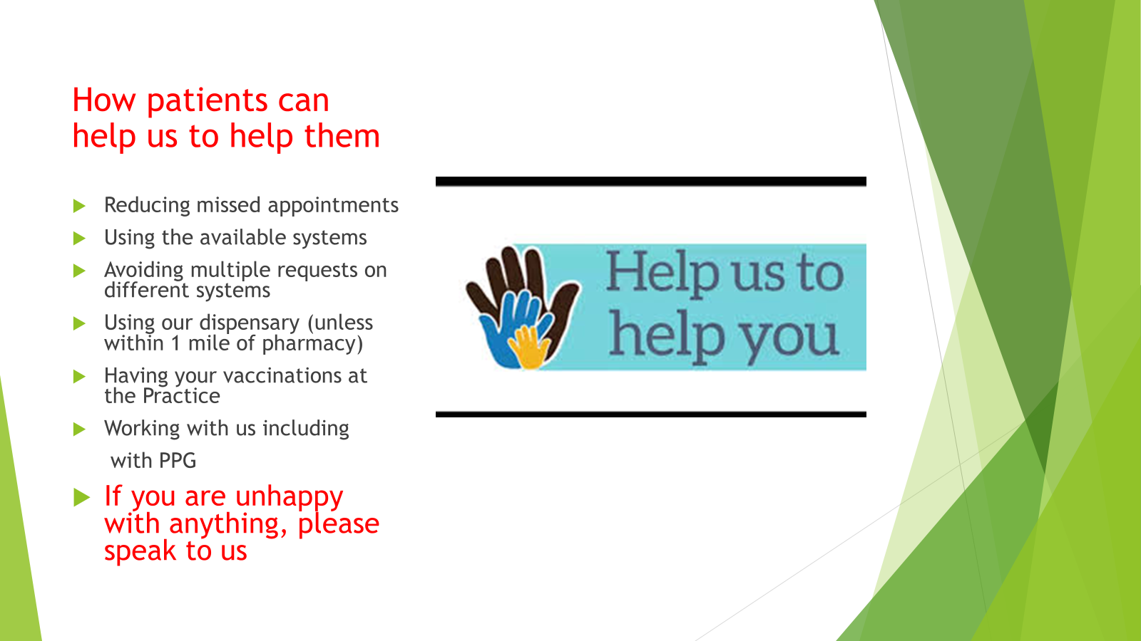

The majority of our patients understand that we are here as a GP Practice as a key part of Primary Care in the NHS, reacting to a wide variety of patient requests for clinical help.

Jess, one of our Practice Nurses, and Immunisation Lead for Parish Fields, explained how the Practice also works proactively with the aim of keeping patients out of hospital, thereby benefitting patients, and reducing the pressures on our secondary care colleagues.

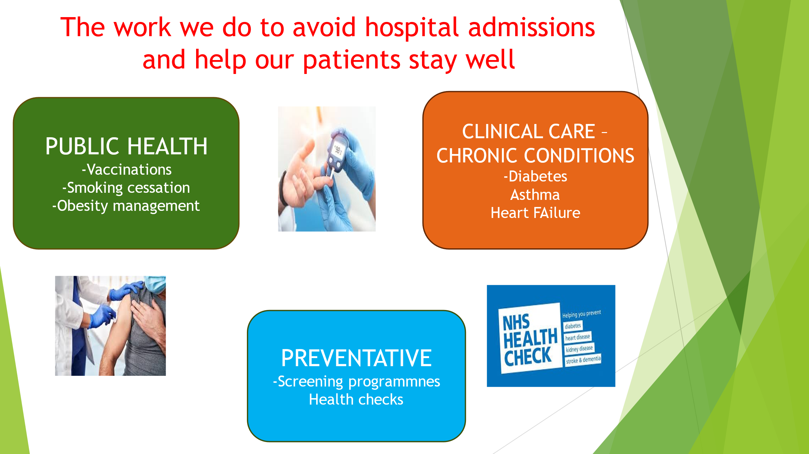

As can be seen from the following information, this includes the management and care for patients with many long-term conditions, as well as providing thousands of vaccinations to our patients each team, including for seasonal flu and Covid-19.

Our Patient Participation Group (PPG) not only supported the organisation of the Practice Open Evening, but were also on hand after the presentation to talk to any patients interested in becoming a member of the PPG at Parish Fields,. I was delighted to hear that 3 more patients volunteered to join out PPG on the evening. Please do contact the Practice if you would like more information about our PPG.



My sincere thanks again to our dedicated PPG members who do so much to support the Practice.

The Open Evening concluded with an opportunity for those attending to ask any questions and provide their feedback.

That’s it for this Newsletter – please do let us know if there are any topics that you would like to see in future newsletters and/or you have any feedback about the Practice.

Simon Round

Practice Manager

19th April 2025