**THE PARISH FIELDS PRACTICE**

**CHRISTMAS AND NEW YEAR OPENING HOURS**

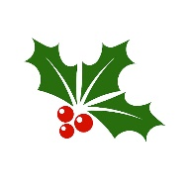 

**The Practice opening hours over Christmas and New Year are as follows:**

**Tuesday 24th December 2024 08:30 – 18:30**

**Wednesday 25th December 2024 CLOSED ALL DAY**

**Thursday 26th December 2024 CLOSED ALL DAY**

**Friday 27th December 2024 08:30-18:30**

**Saturday 28th December 2024 CLOSED ALL DAY**

**Sunday 29th December 2024 CLOSED ALL DAY**

**Monday 30th December 2024 08:30-18:30**

**Tuesday 31st December 2024 08:30-18:30**

**Wednesday 1st January 2025 CLOSED ALL DAY**

**Thursday 2nd January 2025 08:30-18:30**

**Friday 3rd January 2025 08:30-18:30**

**Outside Practice opening hours please telephone 111 for medical assistance**

**At all times, in the event of a medical emergency, please telephone 999 and ask for the ambulance service**

**We would like to wish all of our patients a peaceful Christmas and a happy and healthy New Year**