**THE PARISH FIELDS PRACTICE**

**SEPTEMBER 2024 NEWSLETTER**

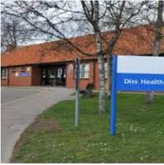

1. **Introduction and August 2024 summary**

**Welcome to our September 2024 newsletter. We hope that all of our patients have managed to have some relaxation in the good weather we experienced throughout the school holidays.**

**The demand on the Practice remained high in August, with almost 6,000 requests received from patients, 3,608 of which were via inbound telephone calls. We will be focussing on our new website later in this newsletter to ensure that our patients can get the best from it.**

**4,496 appointments were booked during August, which was an attendance rate of over 97%, with 121 appointments lost because the patient did not attend and did not let us know beforehand. This takes the year-to-date total for not-attended appointments to 1,119.**

**Thank you to the 298 patients who provided feedback to the Practice in August. Almost 96% of patients rated the Practice “Very Good” or “Good”, which was very encouraging. Your feedback is always appreciated and shared with our staff at regular meetings and at our Patient Participation Group (PPG), including looking at areas where our patients feel we could improve the service provided to them.**

**One piece of feedback we have heard recently is confusion over the check-in screen when patients arrive for their appointment. Specifically, where the screen shows a name once the patient has completed the input of their month and date of birth.**

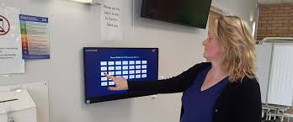

**Where a name is displayed on the screen this will be the name of the clinician with whom you have your appointment (not your own name) and indicates that you have successfully checked-in for your appointment.**

**Our check-in screen has also been enhanced to offer patients the choice of which language the screen is in. Please let us know if there are any additional languages you would like to see on the patient check-in screen.**

1. **Autumn 2024 vaccinations**

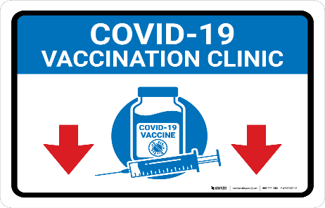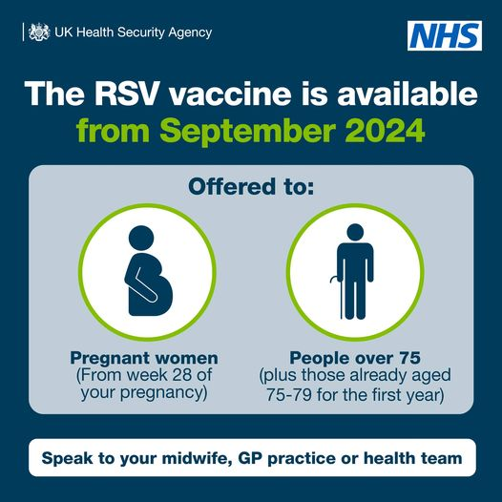

**Our nursing team has been very busy preparing for vaccination clinics for flu, Covid-19 and, new for this year, RSV. Some of our clinics for these vaccinations will be on Saturdays in September and October.**

**Flu Vaccinations**

**Flu vaccination is recommended for those who are most at risk of serious complications if they get flu. For adults, this includes everyone aged 65 years and over, pregnant women, and those with certain long-term health conditions. Further details are available on the following website:**

**https://www.gov.uk/government/publications/flu-vaccine-supply-when-can-you-get-your-vaccination/when-can-you-get-your-flu-vaccine**

**Or please contact the Practice for further advice or information.**

**Covid-19 Vaccinations**

**The Practice is offering eligible patients the opportunity to have their vaccination at the Practice this Autumn. Further details on eligibility for the Autumn 2024 Covid-19 vaccination can be found on the following website:**

**https://ukhsa.blog.gov.uk/2024/08/02/whos-eligible-for-the-2024-covid-19-vaccine-or-autumn-booster/**

**Or, again, please contact the Practice for further advice or information.**

**RSV (Respiratory Syncytial Virus) Vaccinations**

**From 1 September 2024, those who turn 75 and those age 75 to 79 will be eligible for a free vaccine to protect them from respiratory syncytial virus (RSV).**

**RSV is an infectious disease of the airways and lungs. RSV infection often causes symptoms similar to a cold.**

**The link to the Government website, with a guide on RSV vaccine is detailed below, but please contact the Practice if you have any questions:**

**https://www.gov.uk/government/publications/respiratory-syncytial-virus-rsv-vaccination-for-older-adults/your-guide-to-the-rsv-vaccine-for-older-adults**

**Please do support the Practice if you wish to have any of these vaccinations this Autumn, where you can be assured of expert care from our highly experienced nursing team.**

1. **THE PARISH FIELDS PRACTICE NEW WEBSITE**



**Our new website is now live and available to patients at** [**https://parishfields.co.uk/**](https://parishfields.co.uk/)

**The new website has been based upon feedback from our patients who asked us for a website which is easier to use, and we hope that you therefore find the new website achieves this aim.**

**The front page of the website has 6 main tiles:**

* **Appointments – Request for appointments, changes, or cancellations to appointments.**
* **Prescriptions – Ask for a repeat prescription, help with medicines, find a pharmacy.**
* **Sick notes – Request a sick (fit) note for work or find out about self-certification.**
* **Test results – Get your recent test results and find out what to do next.**
* **Register with us – Check our catchment area and register with the surgery.**
* **Contact us – Contact the surgery or what to do when we are closed.**

**There is also information on Local and NHS services and the latest surgery news.**

**When using the Appointment option, can we please ask that the section “*use our nurse or healthcare assistant appointment request*” option is ONLY used for ROUTINE appointment requests for our Nursing Team and NOT requests for an appointment with a GP.**

**The route to request a GP appointment is via the “*Get help for any health problem*” option after clicking on the Appointments tile.**

**If you have any feedback regarding our new website, please do let us know.**

1. **TELEPHONE ACCESS TO THE PRACTICE**



**We are currently working on an initiative which we hope will give those patients who cannot access the Practice online more options via their telephone. We will publish more information on this over the coming months.**

**In the meantime, our Reception Team continue to work extremely hard to minimise telephone call waiting times for patients and we carefully monitor telephone call volumes to aim to manage our resource accordingly. On occasions however, especially at the start of the week and around Bank Holidays, telephone call volumes can reach up to 80 per hour, which means that some waiting time is unfortunately inevitable.**

**That’s it for this month. Thank you to all of our patients for their support of the Practice and their valued feedback.**

**Please do let us know if you would like to see any specific topics covered in future publications of this newsletter.**

**Simon Round**

**Practice Manager**

**9th September 2024**